2021 Winter CIS200 – Programming Assignment 3

Pointers and Linked Lists

Professor: Jie Shen

Release date: Mar. 6, 2021

Due date: Mar. 27, 2021

Student name: Demetrius Johnson

Contents

**Question 1 Unsorted Linked List (30 points)** 3

Source code (USED C++ COMPILER on Microsoft Windows 10) 3

Test data and expected results 3

TEST 1: 4

TEST 2: 4

TEST 3: 5

TEST 4: 5

TEST 5: 6

**Question 2 Sorted linked list 30 points)** 7

Source code (USED C++ COMPILER on Microsoft Windows 10) 7

Test data and expected results 7

TEST 1: 8

TEST 2: 8

TEST 3: 9

TEST 4: 9

TEST 5: 10

**Question 3 Sorted list using Dynamic Array (30 points)** 11

Source code (USED C++ COMPILER on Microsoft Windows 10) 11

Test data and expected results 11

TEST 1: 12

TEST 2: 12

TEST 3: 13

TEST 4: 13

TEST 5: 14

# **Question 1 Unsorted Linked List (30 points)**

## Source code (USED C++ COMPILER on Microsoft Windows 10)

See CPP and H uploads I made in canvas with this document along with the executables.

## Test data and expected results

Test Table:

|  |  |  |  |  |  |  |
| --- | --- | --- | --- | --- | --- | --- |
| Test # | Valid / Invalid Data | Description of test | Input Value | Expected Output | Actual Output | Test Pass / Fail |
| 1 | valid | Task 2 | Float.dat | Output contents in a list from float.dat file | See screenshot | pass |
| 2 | valid | Task 3: Add code to your driver to test the remaining member functions. Delete 2.0, 9.0, and 6.2 from *x* and print the list to be sure they are gone. Bonus: Insert function tested for 55  Although it was already tested from file input | Delete 2.0, 9.0, and 6.2 from *x*  *Insert 55.0 to x* | Output contents of x excluding 2, and 9, and adding 55 | See screenshot | pass |
| 3 | valid | Task 4: Create another instance, y, through the copy constructor such that the content of *y* is the same as that of *x*, but a deep copy should be done. Print out the all the list elements of *y*. | UList<ItemType> y(x); | Contents of y is same as x | See screenshot | pass |
| 4 | valid | Task 5: Declare an instance, z, and assign the content of x to z through the operation “=”. Print out the all the list elements of z. | UList<ItemType> z;  z = x; | Contents of z is same as x | See screenshot | pass |
| 5 | valid | Task 6: Test if 9.0 is in the lists *x* and *y* via the member function: IsThere(ItemType item) and print out the test results. | Isthere 9 for x and y | False for both | See screenshot | pass |

Task 7: What is the Big-O notation for the time complexity of IsThere( ) function?

answer: O(N) since I only implemented 1 while loop in my function that searches from the first node to the last node in the linked list.

### TEST 1:

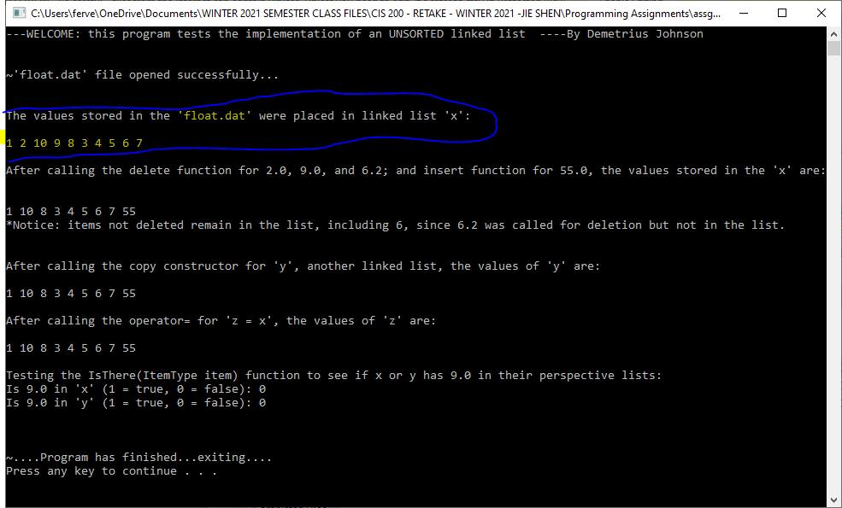

### TEST 2:

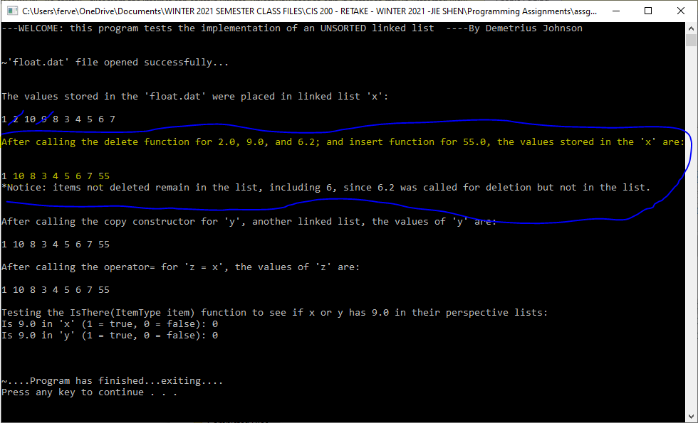

### TEST 3:

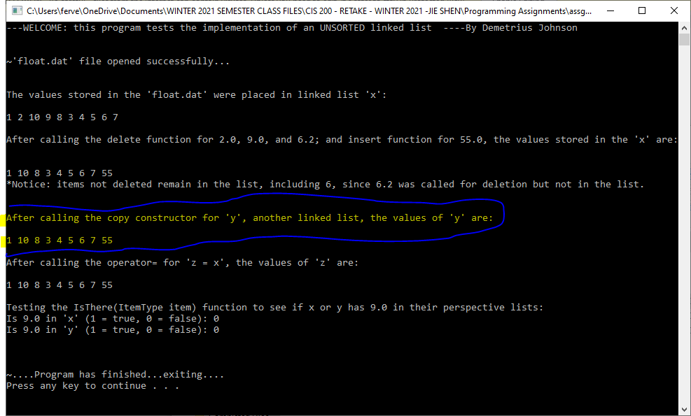

### TEST 4:

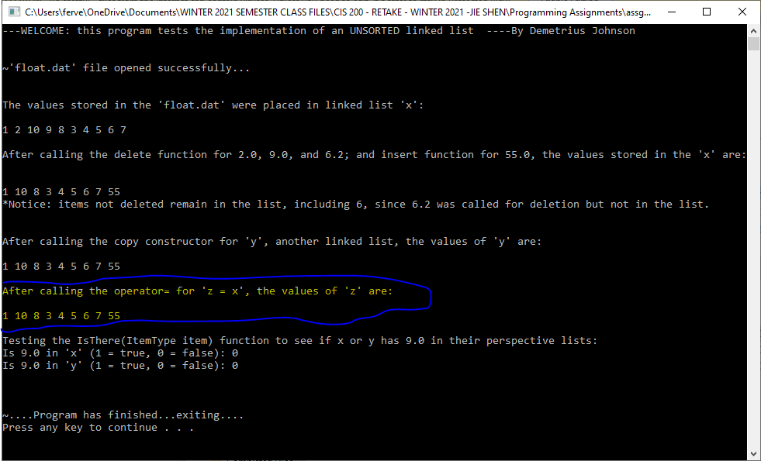

### TEST 5:

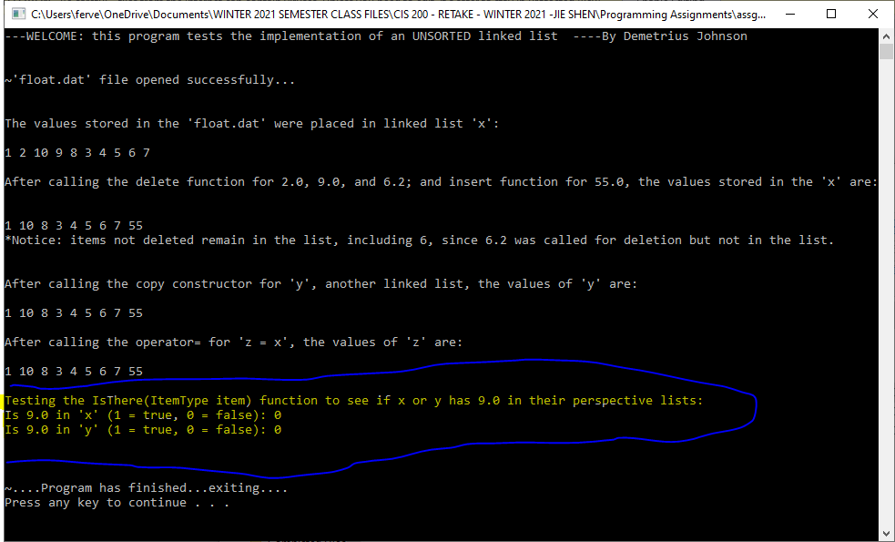

# **Question 2 Sorted linked list 30 points)**

## Source code (USED C++ COMPILER on Microsoft Windows 10)

See CPP and H uploads I made in canvas with this document along with the executables

## Test data and expected results

Test Table:

|  |  |  |  |  |  |  |
| --- | --- | --- | --- | --- | --- | --- |
| Test # | Valid / Invalid Data | Description of test | Input Value | Expected Output | Actual Output | Test Pass / Fail |
| 1 | valid | Task 2 | Float.dat | Output contents in a list from float.dat file in SORTED order | See screenshot | pass |
| 2 | valid | Task 3: Add code to your driver to test the remaining member functions. Delete 2.0, 8.0, and 40 from *x* and print the list to be sure they are gone. Bonus: Insert function tested for 55  Although it was already tested from file input | Delete 2.0, 8.0, and 40.0 from *x*  *Insert 55.0 to x* | Output contents of x excluding 2, and 8, and adding 55 | See screenshot | pass |
| 3 | valid | Task 4: Create another instance, y, through the copy constructor such that the content of *y* is the same as that of *x*, but a deep copy should be done. Print out the all the list elements of *y*. | UList<ItemType> y(x); | Contents of y is same as x | See screenshot | pass |
| 4 | valid | Task 5: Declare an instance, z, and assign the content of x to z through the operation “=”. Print out the all the list elements of z. | UList<ItemType> z;  z = x; | Contents of z is same as x | See screenshot | pass |
| 5 | valid | Task 6: Test if 9.0 is in the lists *x* and *y* via the member function: IsThere(ItemType item) and print out the test results. | Isthere 9 for x and y | TRUE for both | See screenshot | pass |

Task 7: What is the Big-O notation for the time complexity of IsThere( ) function?

answer: O(N) since I only implemented 1 while loop in my function that searches from the first node to the last node in the linked list.

### TEST 1:

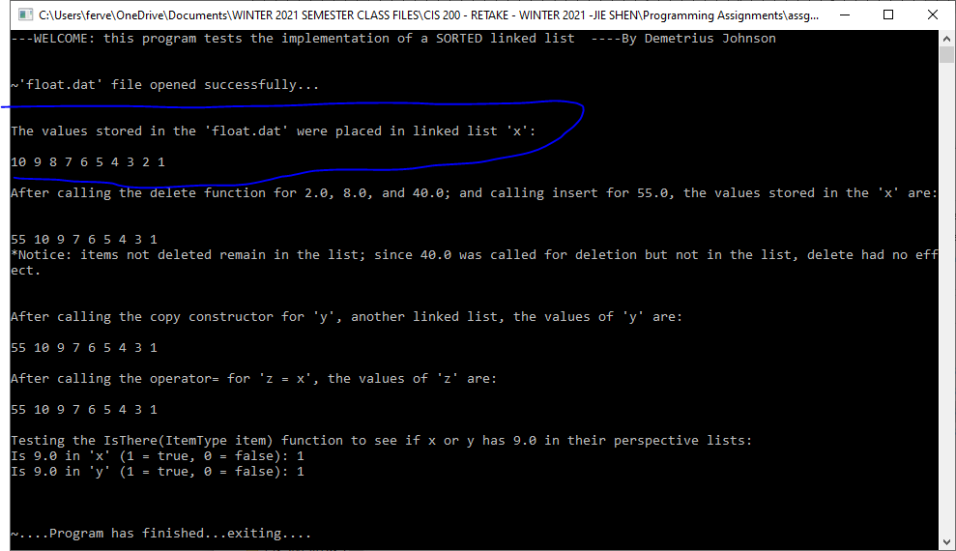

### TEST 2:

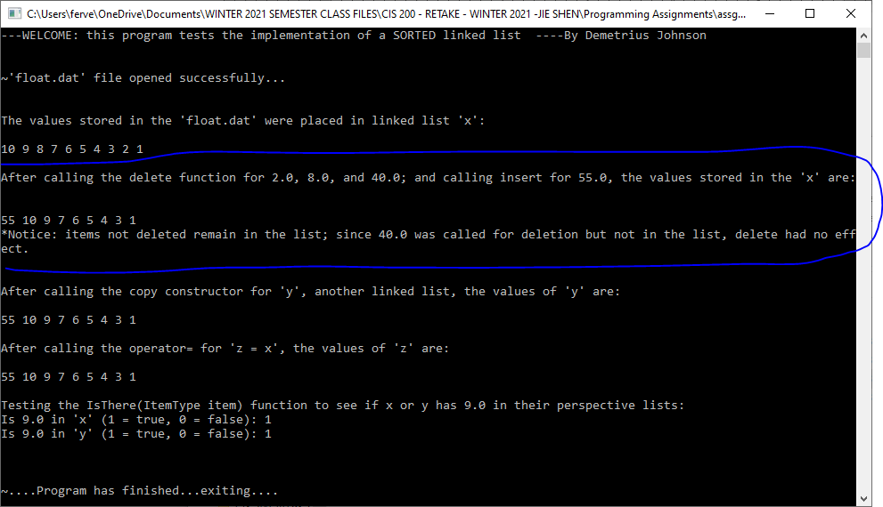

### TEST 3:

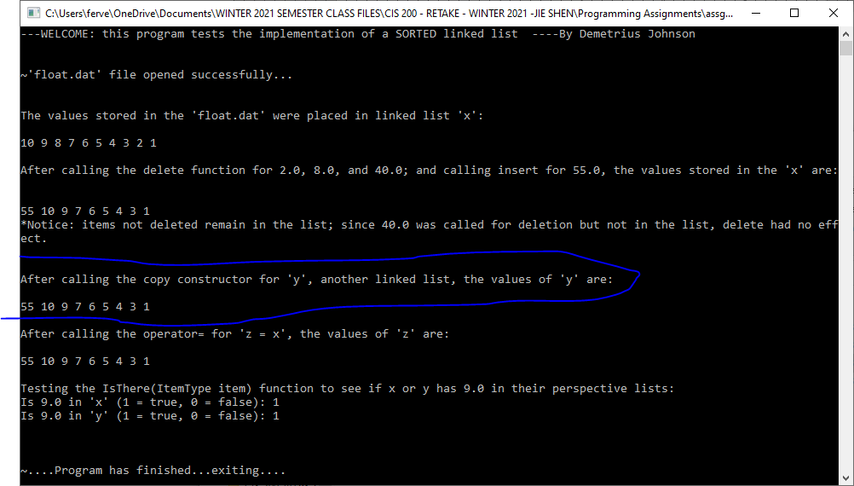

### TEST 4:

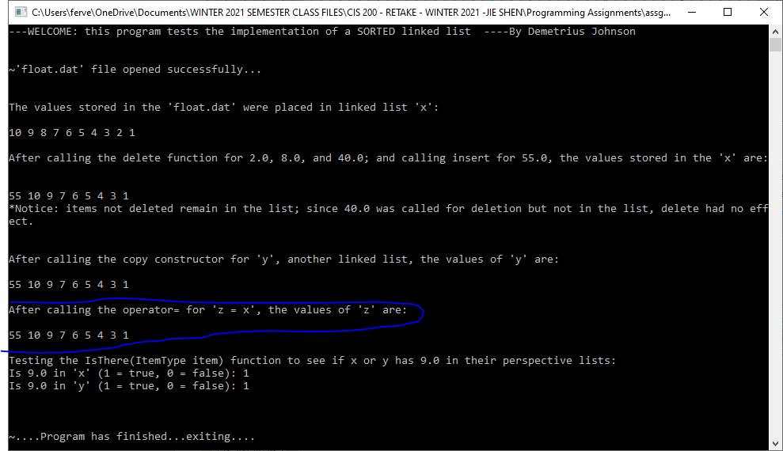

### TEST 5:

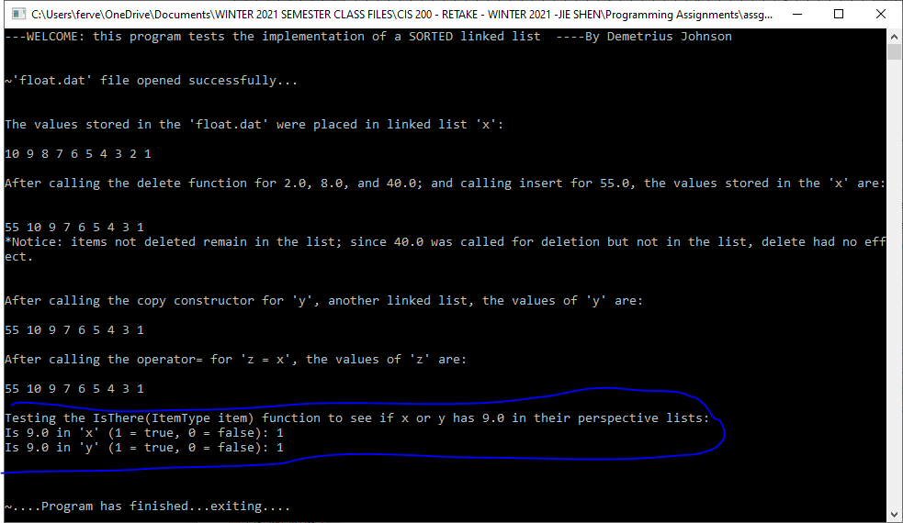

# **Question 3 Sorted list using Dynamic Array (30 points)**

## Source code (USED C++ COMPILER on Microsoft Windows 10)

See CPP and H uploads I made in canvas with this document along with the executables

## Test data and expected results

Test Table:

|  |  |  |  |  |  |  |
| --- | --- | --- | --- | --- | --- | --- |
| Test # | Valid / Invalid Data | Description of test | Input Value | Expected Output | Actual Output | Test Pass / Fail |
| 1 | valid | Task 2; also test Length() | Float.dat | Output contents in a list from float.dat file in SORTED order | See screenshot | pass |
| 2 | valid | Task 3: Add code to your driver to test the remaining member functions. Delete 2.0, 8.0, and 40 from *x* and print the list to be sure they are gone. Bonus: Insert function tested for 55  Although it was already tested from file input | Delete 2.0, 8.0, and 40.0 from *x*  *Insert 55.0 to x* | Output contents of x excluding 2, and 8, and adding 55 | See screenshot | pass |
| 3 | valid | Task 4: Create another instance, y, through the copy constructor such that the content of *y* is the same as that of *x*, but a deep copy should be done. Print out the all the list elements of *y*. | UList<ItemType> y(x); | Contents of y is same as x | See screenshot | pass |
| 4 | valid | Task 5: Declare an instance, z, and assign the content of x to z through the operation “=”. Print out the all the list elements of z. | UList<ItemType> z;  z = x; | Contents of z is same as x | See screenshot | pass |
| 5 | valid | Task 6: Test if 9.0 is in the lists *x* and *y* via the member function: IsThere(ItemType item) and print out the test results. | Isthere 9 for x and y | TRUE for both | See screenshot | pass |

Task 7: What is the Big-O notation for the time complexity of IsThere( ) function?

answer: O(N^2) since in the while loop, every element has to be shifted down as well depending on N in another loop; total loops = 2; N^2 time complexity.

### TEST 1:

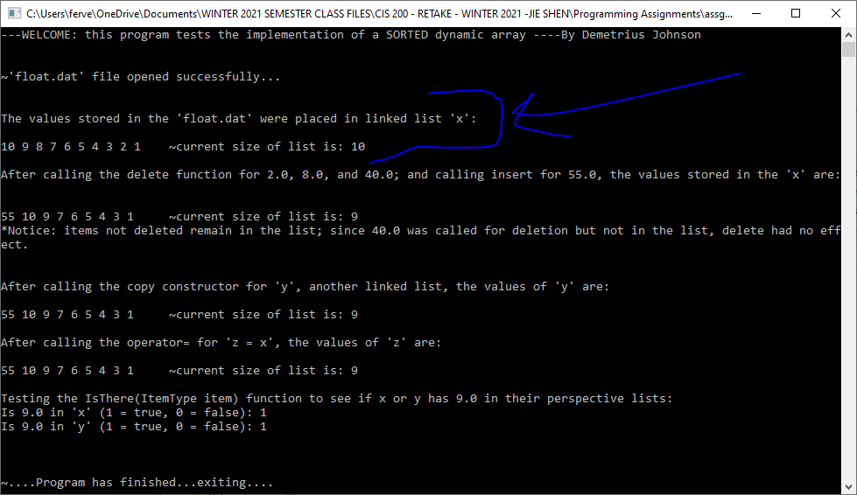

### TEST 2:

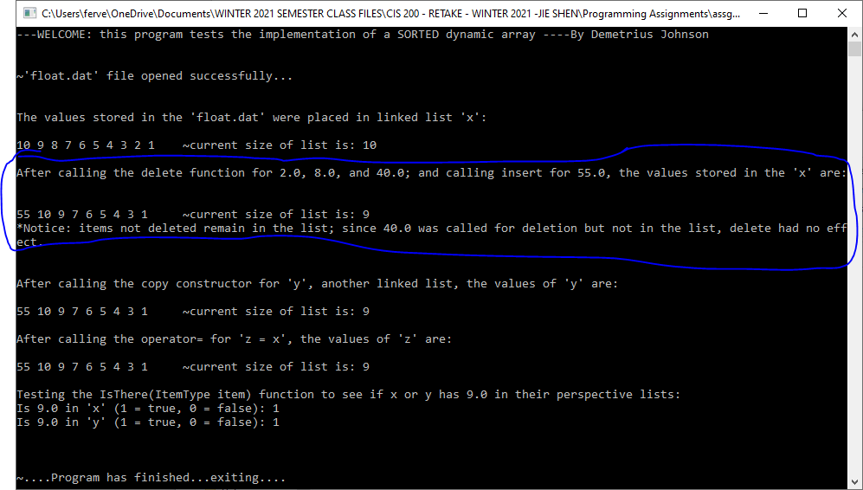

### TEST 3:

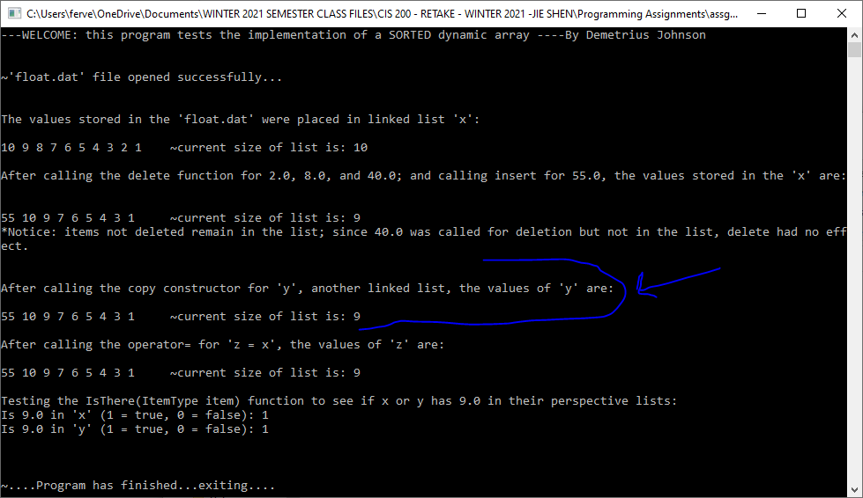

### TEST 4:

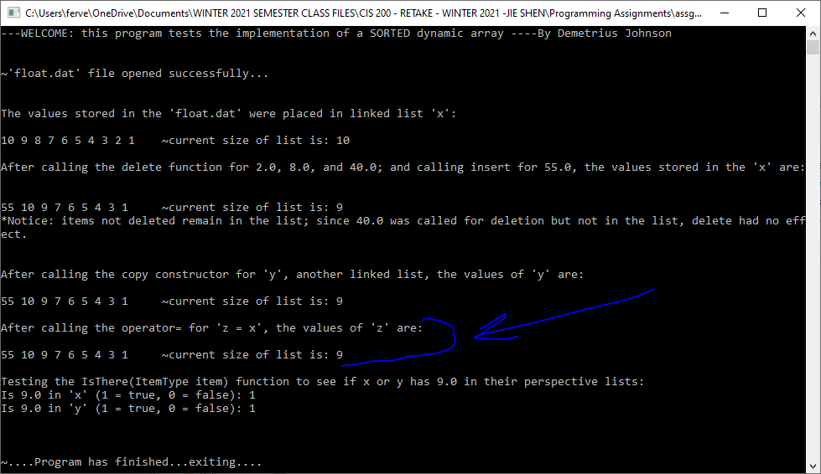

### TEST 5:

